**CIT 352 Chapter 9**

Name: Celeste George

Complete all Projects by executing every step in each project. For those steps listed below, follow the specified instruction.

Project 9-1

Step 3

* Which process has a Process ID of 1? (PID=1)  
  /user/lib/systemd/systemd
* What character do most processes have in the terminal column (tty)?

?

* What does this character in the terminal column indicate?

Daemon or kernel because it is not showing which terminal is running exactly

* Which user started most of these processes?

Shows the root as the user

* Which process is the parent of most processes?

Parent process

Project 9-2

Step 8

* Why did this command work when the others did not?

Kill -9 PID forced the kill on bash

Project 9-3

Step 13

* Insert the screen capture

Project 9-4

Step 3

* Number of processes: 230
* Number of sleeping processes: 229
* Amount of total memory (K): 1969.6
* Amount of total swap memory (K): 6024.0

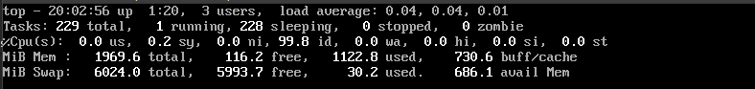

Project 9-5

Step 15

Note: Newer versions of Fedora have removed this file.

#cat /etc/rcron.d/raid-check

0 1 * * Sun root /usr/sbin/raid-check

* Given the file contents shown above for the missing file, when does the job run?

Once a week on Sunday at 1am by default

Project 9-6

Step 6

* Insert the screen capture

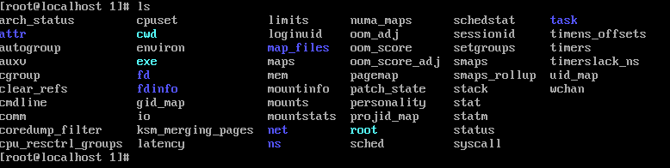

**Command Reference** (List all new commands you learned in this chapter)

Cat meminfo

At now + 1 minute

Date > /root/datefile

Who >> /root/datefile

Crontab -l

Crontab -e

Fg %